KYUNGDONG UNIVERSITY GLOBAL


Quantifying Behavioral Changes Included by Mobile Application Usage Using Passive Sensing and Machine Learning

By

Tamang Anil 2417132
Thing Suman 2417121
Mahato Roshan Kumar 2417104
Thakur Subodh 2417134
Hitan Nirajan 2417140

Supervisor
Dr. Ghulam Sarwar

Bachelor in Smart Computing(2024-2028)

DEPARTMENT OF SMART COMPUTING

KYUNGDONG UNIVERSITY GLOBAL


Quantifying Behavioral Changes Included by Mobile Application Usage Using Passive Sensing and Machine Learning
A project presented to
KYUNGDONG UNIVERSITY GLOBAL

In partial fulfillment
of the requirement for the course research methodology

Bachelor in Smart Computing(2024-2028)

by

Tamang Anil 2417132
Thing Suman 2417121
Mahato Roshan Kumar 2417104
Thakur Subodh 2417134
Hitan Nirajan 2417140
DEPARTMENT OF SMART COMPUTING

ABBREVIATIONS

SRS | Software Require Specification
PC | Personal Computer

TABLE OF CONTENTS
- INTRODUCTION 52
  - Brief 52
  - Relevance to Course Modules 52
  - Project Background 52
  - Literature Review 52
  - Analysis from Literature Review (in the context of your project) 52
  - Methodology and Software Lifecycle for This Project 52
    - The rationale behind Selected Methodology 52
- PROBLEM DEFINITION 53
  - Problem Statement 53
  - Deliverables and Development Requirements 53
- REQUIREMENT ANALYSIS 53
  - Use Cases Diagram(s) 54
  - Detailed Use Case 54
  - Functional Requirements 54
  - Non-Functional Requirements 54
- DESIGN AND ARCHITECTURE 55
  - System Architecture 55
  - Data Representation [Diagram + Description] 55
  - Process Flow/Representation 55
  - Design Models [along with descriptions] 55
- IMPLEMENTATION 56
  - Algorithm 56
  - External APIs 56
  - User Interface 56
- TESTING AND EVALUATION 57
  - Manual Testing 57
    - System testing 57
    - Unit Testing 57
    - Functional Testing 58
    - Integration Testing 58
  - Automated Testing 59
Tools used: 59
- CONCLUSION AND FUTURE WORK 60
  - Conclusion 60
  - Future Work 60
- REFERENCES 61

LIST OF FIGURES
Figure 1.1 Block Diagram 8
Figure 2.1 Use Case Diagram 9

INTRODUCTION
This chapter provides an overview of the project. The first paragraph of every chapter provide the chapter summary.

Brief
This study aims to analyze how mobile application usage affects human behavior using passive sensing and machine learning. Data such as screen time, app usage, and physical activity is collected automatically and analyzed to detect behavioral changes.

Relevance to Course Modules
Machine Learning / AI: For prediction and pattern analysis Data Science: For data processing and analysis Software Engineering: For system design and development Mobile Computing: For data collection through smartphones

Project Background
Mobile applications are widely used in daily life and influence habits such as sleep, activity, and productivity. Passive sensing and machine learning provide new ways to measure and understand these behavioral changes.

Literature Review
High mobile usage affects mental health and productivity Passive sensing is useful for collecting behavioral data Machine learning improves behavior prediction accuracy

Analysis from Literature Review
Lack of combined use of passive sensing and ML Limited real-time behavior analysis.

Methodology and Software Lifecycle for This Project
Methodology:
Collect data (passive sensing)
Preprocess data
Apply machine learning models
Analyze results
Software Lifecycle (SDLC)
Requirement Analysis
Design
Implementation
Testing
The rationale behind Selected Methodology
Passive sensing provides accurate and real-time data Machine learning handles large data and finds patterns Quantitative approach ensures measurable results

PROBLEM DEFINITION
This chapter discusses the precise problem to be solved. It should extend to include the outcome.

Problem Statement
Mobile application usage affects users’ behavior (sleep, activity, productivity), but it is difficult to measure accurately because current methods rely on self-reported data. There is no efficient system to automatically track and analyze these changes using real-time data.

Deliverable and Development Requirements
Mobile application usage affects users’ behavior (sleep, activity, productivity), but it is difficult to measure accurately because current methods rely on self-reported data. There is no efficient system to automatically track and analyze these changes using real-time data.

REQUIREMENT ANALYSIS
The following parts of the Software Requirements Specification (SRS) report should be included in this chapter.
Diagram Detailed
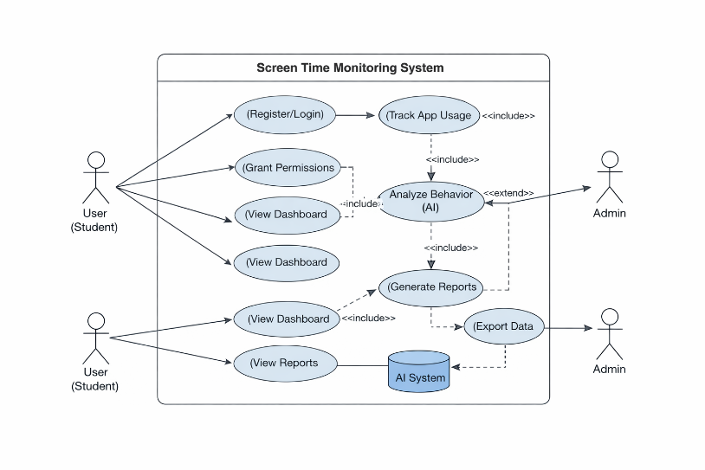
fig 1:Use Case Diagram

Use Cases
The system is a Mobile Behavior Analysis Application that monitors user activity and analyzes behavioral patterns using smartphone data.
Primary Actors
- User – Uses the mobile application
- System (AI Engine) – Processes and analyzes behavior
- Admin/Researcher – Monitors aggregated insights

Functional Requirements
User Management
- FR-01: System shall allow users to register and log in
- FR-02: System shall authenticate users securely
Data Collection
- FR-03: System shall collect app usage statistics
- FR-04: System shall capture sensor data (accelerometer, screen time, etc.)
- FR-05: System shall log user activity continuously (with consent)
Data Processing & Analysis
- FR-06: System shall preprocess collected data
- FR-07: System shall apply machine learning models to detect behavior patterns
- FR-08: System shall classify user behavior (e.g., high usage, low activity)
Reporting & Visualization
- FR-09: System shall provide a dashboard for users
- FR-10: System shall generate behavioral reports
- FR-11: System shall visualize trends using charts
Notifications
- FR-12: System shall send alerts for excessive usage
- FR-13: System shall provide recommendations for behavior improvement
Admin Features
- FR-14: Admin shall access anonymized data
- FR-15: Admin shall export reports

Non-Functional Requirements

Performance
- NFR-01: System shall process data within 2 seconds for real-time feedback
- NFR-02: System shall support at least 10,000 concurrent users
Security & Privacy
- NFR-03: System shall encrypt user data
- NFR-04: System shall comply with privacy regulations (e.g., GDPR-like standards)
- NFR-05: User data shall be anonymized for research
Usability
- NFR-06: System shall provide an intuitive user interface
- NFR-07: Users shall access reports within 3 clicks
Reliability
- NFR-08: System shall have 99% uptime
- NFR-09: System shall handle failures gracefully
Scalability
- NFR-10: System shall scale horizontally with increasing users
Maintainability
- NFR-11: System shall be modular for easy updates
- NFR-12: Code shall follow standard documentation practices

DESIGN AND ARCHITECTURE
The following parts of the Software Design Description (SDD) report are included in this chapter.

System Architecture
The system follows a layered architecture consisting of: Data Collection Layer: Collects passive sensing data (GPS, app usage, sensors) from mobile devices Data Processing Layer: Cleans and preprocesses collected data Machine Learning Layer: Analyzes data to detect behavioral patterns Presentation Layer: Displays insights through a dashboard or reports

Data Representation [Diagram + Description]
Data is represented in structured format including: User ID, timestamp App usage duration and frequency Sensor data (location, movement, screen activity)
This data is stored in a database and used for analysis and prediction.
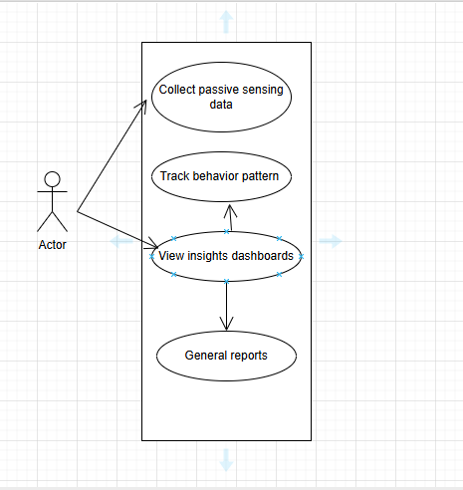
Tfig 2: Use Case Diagram

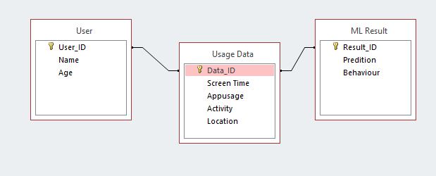
fig 3:ER diagram

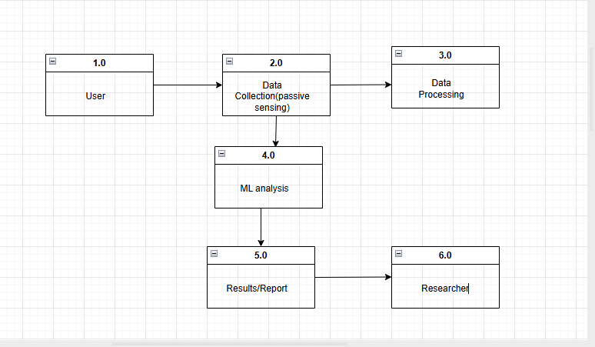
fig 4:DFD Diagram

Process Flow/Representation
Data is collected from mobile sensors Data is preprocessed and cleaned Machine learning models analyze behavior patterns Results are generated and visualized for users

Design Models
Use Case Model: Shows interaction between user and system
Data Flow Diagram (DFD): Represents flow of data through system
Architecture Diagram: Shows system components and connections

IMPLEMENTATION
The system is implemented to automatically collect user behavior data from mobile devices using passive sensing and analyze it using machine learning models to detect behavioral changes.

Algorithm
Collect data (screen time, app usage, activity) Preprocess data (clean and normalize) Extract important features Apply ML models (Decision Tree, Random Forest) Predict behavior (Normal / High / Risky)

External APIs
Google Fit API: collects physical activity data
Usage Stats API: tracks app usage and screen time
Location API: monitors movement patterns

User Interface

Back End
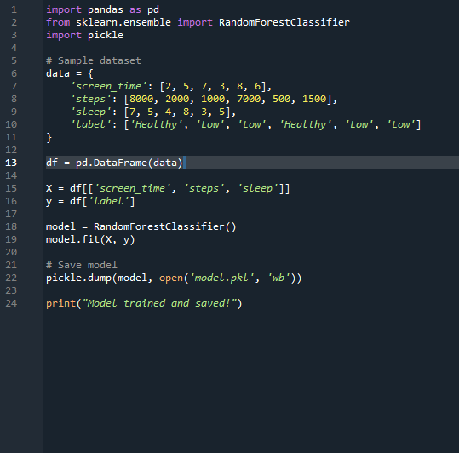
fig 5:Code using python

Front End

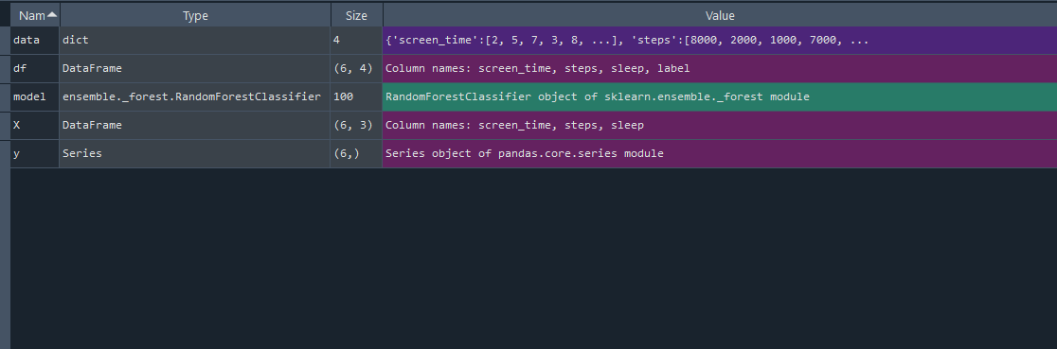
fig:Output

TESTING AND EVALUATION
Testing and Evaluation Testing and evaluation ensure that the system accurately collects user data, processes it, and predicts behavioral changes reliably.
Testing focuses on verifying system functionality, while evaluation measures the performance of predictive models using metrics such as accuracy, precision, recall, and error rates.

Types of Testing
1. Manual Testing
Manual testing involves human interaction to verify whether the application behaves as expected. For example, checking if screen time, app usage, or sensor data (like GPS) is correctly recorded. It is useful for identifying usability issues in early development stages.

2. Unit Testing
Unit testing validates individual components of the system. Each function, such as data collection from sensors or preprocessing modules, is tested independently to ensure correctness before integration.

3. Integration Testing
Integration testing ensures that different modules work together properly. For instance, verifying the smooth flow of data from passive sensors to preprocessing modules and then to the machine learning model.

4. Functional Testing
Functional testing checks whether the system meets the required objectives. It ensures that the application correctly identifies and quantifies behavioral changes, such as increased mobile usage or reduced physical activity.

5. System Testing
System testing evaluates the complete system as a whole. It verifies end-to-end performance, including data collection, processing, prediction, and output visualization in real-world scenarios.

6. Automated Testing Automated testing uses scripts and tools to perform repeated testing efficiently. It is especially useful for validating machine learning models after updates and ensuring consistent performance over time.

Tools Used Programming & Machine Learning Tools:
Python – for data processing and model development
TensorFlow / Scikit-learn – for building predictive models
Testing Frameworks:
PyTest – for unit and integration testing
JUnit – for Java-based testing

Mobile Testing Tools:
Appium – for automated mobile app testing
Firebase Test Lab – for real-device testing
Data Analysis Tools: Pandas and NumPy – for evaluation and performance analysis

CONCLUSION AND FUTURE WORK
This project presents a system for analyzing behavioral changes caused by mobile application usage using passive sensing and Machine Learning. By collecting real-time data such as screen time, app usage, and physical activity, the system overcomes the limitations of traditional self-reported methods. The integration of data processing and machine learning models enables accurate detection of user behavior patterns. Additionally, proper testing and evaluation ensure that the system is reliable, efficient, and suitable for real-world applications. Overall, the project demonstrates the effectiveness of combining mobile sensing and intelligent analysis to better understand user behavior.
Future Work
Improve data collection from mobile sensors Optimize Machine Learning models for better accuracy Implement basic real-time behavior detection Develop a simple dashboard for visualization Apply automated testing for system reliability Evaluate performance using accuracy and related metrics Add basic user recommendations (e.g., screen time alerts)
Reference:
- Wikipedia
- google

